Практическая работа
для закрепления лексических навыков по темам “Food” и “Jobs”

Швайгерт Кристина Владимировна

МБОУ СОШ № 19 г. Междуреченск

учитель английского языка

Ex. 1 Match the two lists to make sentences describing certain jobs.

- A hairdresser  - A vet  - A carpenter  - A cook  - A pilot  - A stewardess  - A militiaman  - A racing driver  - A nurse  - A nursery school teacher  - A waiter  - A clown  - A farmer  - A postman  - A banker  - A builder | - a) teaches small children  - b) flies airplanes.  - c) looks after air passengers.  - d) serves people food.  - e) makes things of wood.  - f) cuts people’s hair.  - g) drives fast cars.  - h) looks after sick people.  - i) regulates traffic.  - j) works on a farm.  - k) cures sick animals.  - l) makes people laugh.  - m) makes food.  - n) builds houses.  - o) counts money  - p) brings letter

Ex. 2 Choose from the box gender-neutral names for the given professions.
Mail carrier, congressional representative, salesperson (2), bar person, police officer (2), flight attendant, chairperson, firefighter, business executive (2)
- Chairman _____________________
- Businessman _____________________
- Businesswoman _____________________
- Mailman _____________________
- Stewardess _____________________
- Policewoman _____________________
- Policeman _____________________
- Salesman _____________________
- Saleswoman _____________________
- Barman _____________________
- Fireman _____________________
- Congressman _____________________

Ex. 3 Use the words for each category.
Chocolate, potato, tea, steak, pear, carrot, garlic, cake, pineapple, broccoli, wine, water, peach, coffee, ice cream, tomato, ham, watermelon, cookies.
MEAT:

DRINKS:

DESSERTS:

FRUIT:

VEGETABLES:

Ex. 4 Guess the word.

- You need me to make a sandwich or toast. – B_________
- I’m yellow or white. I’m made from milk. People like me on their pizza. — C___________
- People eat us fried, boiled or scrambled. — E_______
- I’m a very popular fast food with a sausage in the middle. — H______________
- I’m a long yellow fruit. — B_____________
- Rabbits love this orange vegetable. – C______________

Ex. 5. Look at the picture and say true or false.
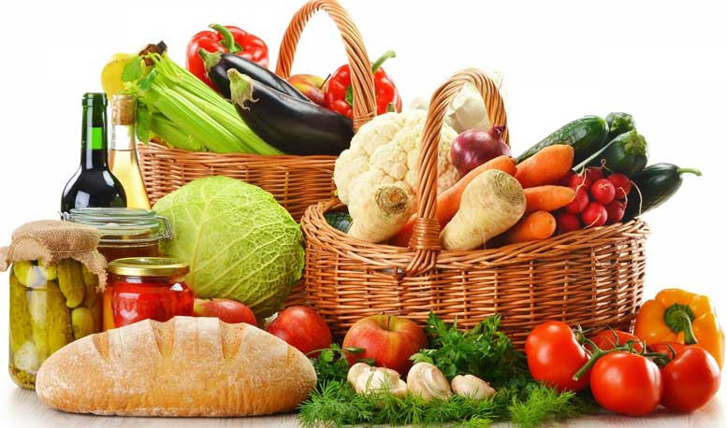

- THERE IS SOME COFFEE
- THERE ARE SOME TOMATOES
- THERE ISN’T ANY MILK
- THERE IS SOME TEA
- THERE AREN’T ANY EGGS
- THERE ARE SOME COOKIES
- THERE IS SOME BACON
- THERE IS SOME BREAD
- THERE ARE SOME MUSHROOMS
- THERE ARE SOME PANCAKES
- THERE IS A CABBAGE
- THERE ARE SOME APPLES

